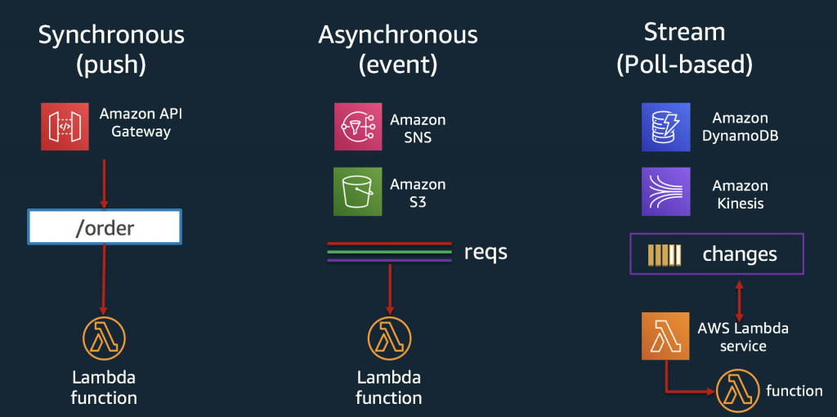

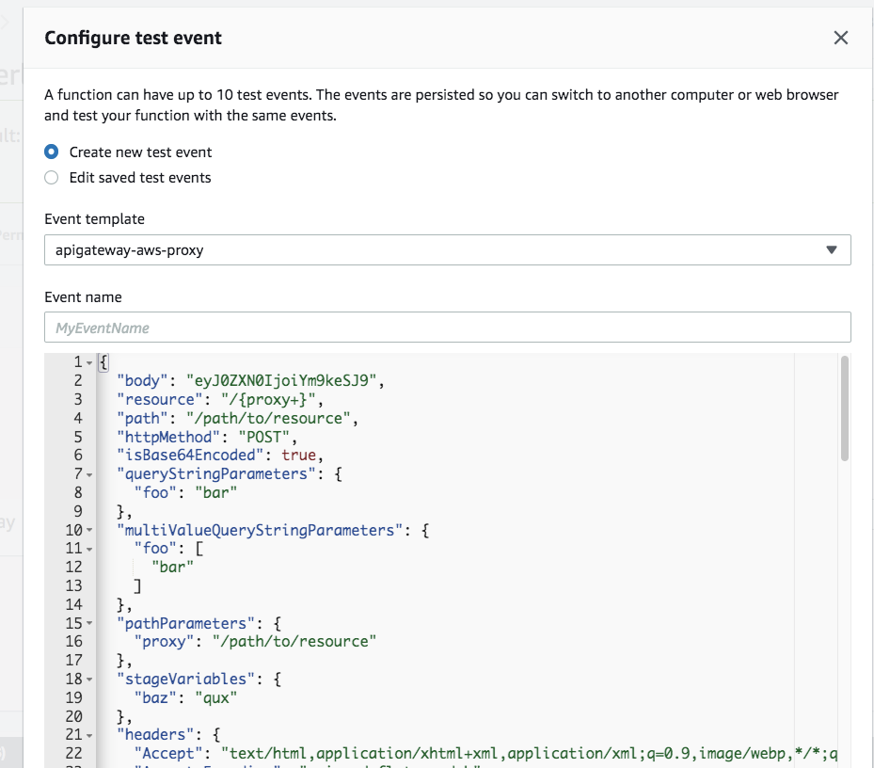

{

"body": "eyJ0ZXN0IjoiYm9keSJ9",

"resource": "/{proxy+}",

"path": "/path/to/resource",

"httpMethod": "POST",

"isBase64Encoded": true,

"queryStringParameters": {

"foo": "bar"

},

**"multiValueQueryStringParameters": {**

**"foo": [**

**"bar"**

**]**

**},**

**"pathParameters": {**

**"proxy": "/path/to/resource"**

**},**

"stageVariables": {

"baz": "qux"

},

"headers": {

"Accept": "text/html,application/xhtml+xml,application/xml;q=0.9,image/webp,*/*;q=0.8",

"Accept-Encoding": "gzip, deflate, sdch",

"Accept-Language": "en-US,en;q=0.8",

"Cache-Control": "max-age=0",

"CloudFront-Forwarded-Proto": "https",

"CloudFront-Is-Desktop-Viewer": "true",

"CloudFront-Is-Mobile-Viewer": "false",

"CloudFront-Is-SmartTV-Viewer": "false",

"CloudFront-Is-Tablet-Viewer": "false",

"CloudFront-Viewer-Country": "US",

"Host": "1234567890.execute-api.us-east-1.amazonaws.com",

"Upgrade-Insecure-Requests": "1",

"User-Agent": "Custom User Agent String",

"Via": "1.1 08f323deadbeefa7af34d5feb414ce27.cloudfront.net (CloudFront)",

"X-Amz-Cf-Id": "cDehVQoZnx43VYQb9j2-nvCh-9z396Uhbp027Y2JvkCPNLmGJHqlaA==",

"X-Forwarded-For": "127.0.0.1, 127.0.0.2",

"X-Forwarded-Port": "443",

"X-Forwarded-Proto": "https"

},

"multiValueHeaders": {

"Accept": [

"text/html,application/xhtml+xml,application/xml;q=0.9,image/webp,*/*;q=0.8"

],

"Accept-Encoding": [

"gzip, deflate, sdch"

],

"Accept-Language": [

"en-US,en;q=0.8"

],

"Cache-Control": [

"max-age=0"

],

"CloudFront-Forwarded-Proto": [

"https"

],

"CloudFront-Is-Desktop-Viewer": [

"true"

],

"CloudFront-Is-Mobile-Viewer": [

"false"

],

"CloudFront-Is-SmartTV-Viewer": [

"false"

],

"CloudFront-Is-Tablet-Viewer": [

"false"

],

"CloudFront-Viewer-Country": [

"US"

],

"Host": [

"0123456789.execute-api.us-east-1.amazonaws.com"

],

"Upgrade-Insecure-Requests": [

"1"

],

"User-Agent": [

"Custom User Agent String"

],

"Via": [

"1.1 08f323deadbeefa7af34d5feb414ce27.cloudfront.net (CloudFront)"

],

"X-Amz-Cf-Id": [

"cDehVQoZnx43VYQb9j2-nvCh-9z396Uhbp027Y2JvkCPNLmGJHqlaA=="

],

"X-Forwarded-For": [

"127.0.0.1, 127.0.0.2"

],

"X-Forwarded-Port": [

"443"

],

"X-Forwarded-Proto": [

"https"

]

},

"requestContext": {

"accountId": "123456789012",

"resourceId": "123456",

"stage": "prod",

"requestId": "c6af9ac6-7b61-11e6-9a41-93e8deadbeef",

"requestTime": "09/Apr/2015:12:34:56 +0000",

"requestTimeEpoch": 1428582896000,

"identity": {

"cognitoIdentityPoolId": null,

"accountId": null,

"cognitoIdentityId": null,

"caller": null,

"accessKey": null,

"sourceIp": "127.0.0.1",

"cognitoAuthenticationType": null,

"cognitoAuthenticationProvider": null,

"userArn": null,

"userAgent": "Custom User Agent String",

"user": null

},

"path": "/prod/path/to/resource",

"resourcePath": "/{proxy+}",

"httpMethod": "POST",

"apiId": "1234567890",

"protocol": "HTTP/1.1"

}

}

## Dynamo DB event

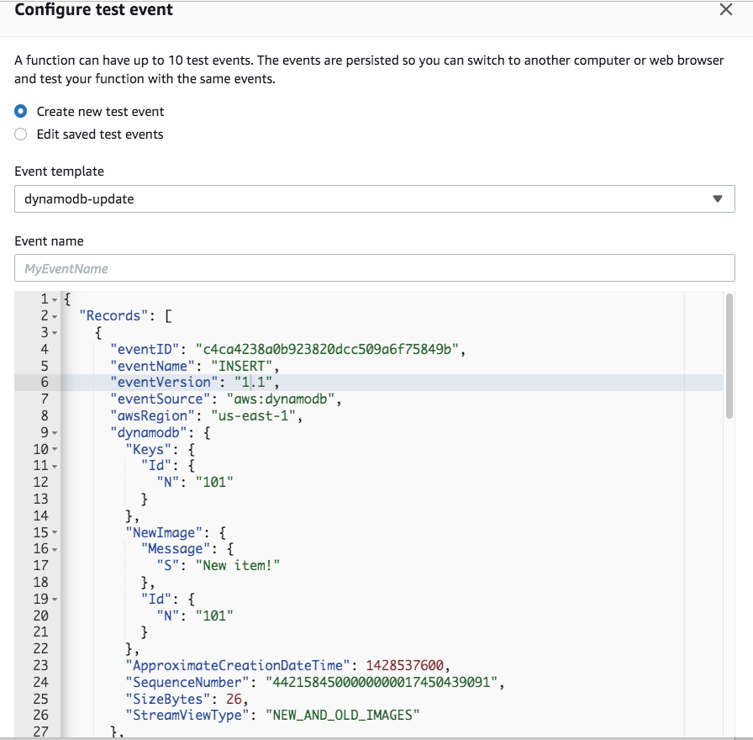

{

"Records": [

{

**"eventID": "c4ca4238a0b923820dcc509a6f75849b",**

**"eventName": "INSERT",**

"eventVersion": "1.1",

"eventSource": "aws:dynamodb",

"awsRegion": "us-east-1",

"dynamodb": {

"Keys": {

"Id": {

"N": "101"

}

},

"NewImage": {

"Message": {

"S": "New item!"

},

"Id": {

"N": "101"

}

},

"ApproximateCreationDateTime": 1428537600,

"SequenceNumber": "4421584500000000017450439091",

"SizeBytes": 26,

"StreamViewType": "NEW_AND_OLD_IMAGES"

},

"eventSourceARN": "arn:aws:dynamodb:us-east-1:123456789012:table/ExampleTableWithStream/stream/2015-06-27T00:48:05.899"

},

{

**"eventID": "c81e728d9d4c2f636f067f89cc14862c",**

**"eventName": "MODIFY",**

"eventVersion": "1.1",

"eventSource": "aws:dynamodb",

"awsRegion": "us-east-1",

"dynamodb": {

"Keys": {

"Id": {

"N": "101"

}

},

"NewImage": {

"Message": {

"S": "This item has changed"

},

"Id": {

"N": "101"

}

},

"OldImage": {

"Message": {

"S": "New item!"

},

"Id": {

"N": "101"

}

},

"ApproximateCreationDateTime": 1428537600,

"SequenceNumber": "4421584500000000017450439092",

"SizeBytes": 59,

"StreamViewType": "NEW_AND_OLD_IMAGES"

},

"eventSourceARN": "arn:aws:dynamodb:us-east-1:123456789012:table/ExampleTableWithStream/stream/2015-06-27T00:48:05.899"

},

{

**"eventID": "eccbc87e4b5ce2fe28308fd9f2a7baf3",**

**"eventName": "REMOVE",**

"eventVersion": "1.1",

"eventSource": "aws:dynamodb",

"awsRegion": "us-east-1",

"dynamodb": {

"Keys": {

"Id": {

"N": "101"

}

},

"OldImage": {

"Message": {

"S": "This item has changed"

},

"Id": {

"N": "101"

}

},

"ApproximateCreationDateTime": 1428537600,

"SequenceNumber": "4421584500000000017450439093",

"SizeBytes": 38,

"StreamViewType": "NEW_AND_OLD_IMAGES"

},

"eventSourceARN": "arn:aws:dynamodb:us-east-1:123456789012:table/ExampleTableWithStream/stream/2015-06-27T00:48:05.899"

}

]

}

Dynamodb streams